**ASP.net Notes**

**Week#01 14-02-2024**

**ASP.Net Full stack Foundation(1st week)**

**Step#01**

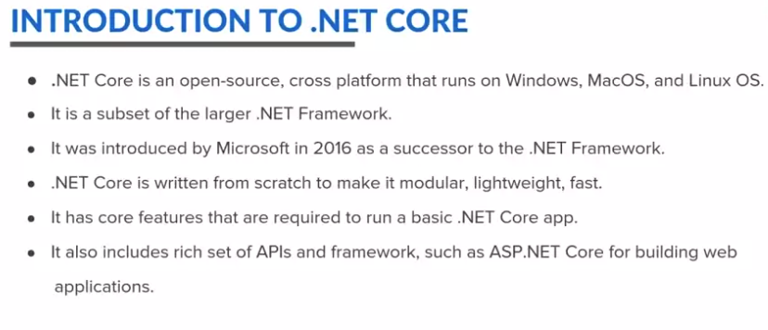

**Step#01**

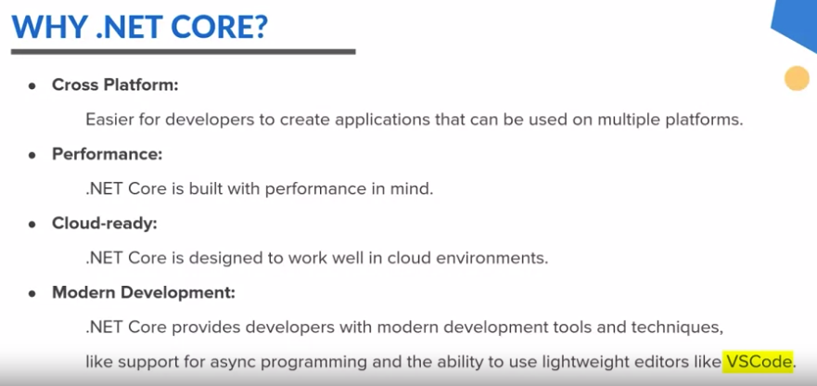

**Step#03**

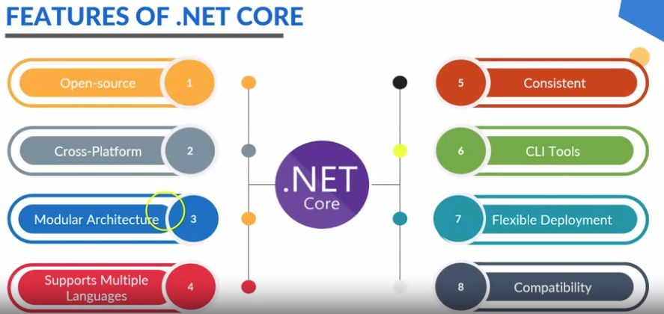

**Step#04**

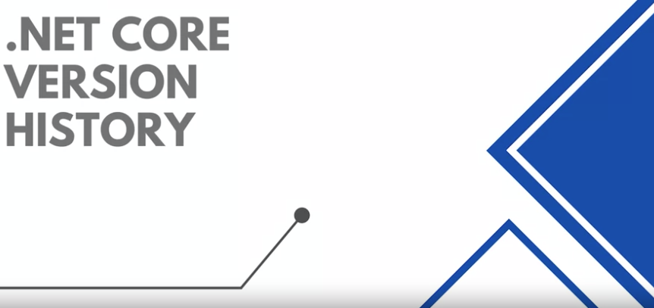

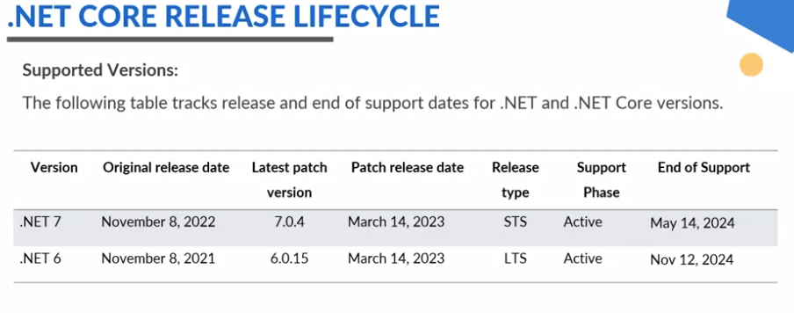

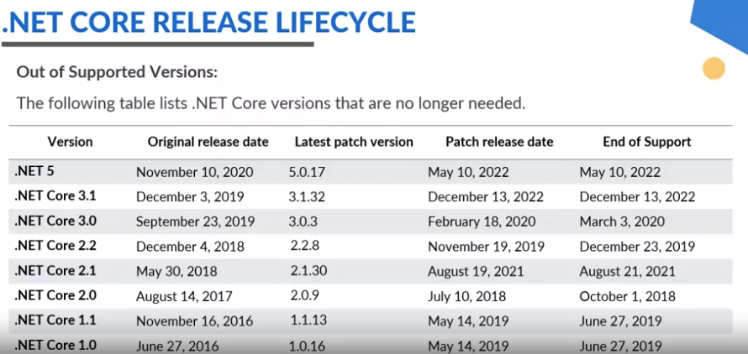

**Step#05**

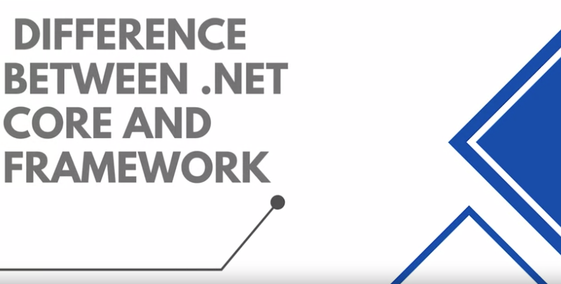

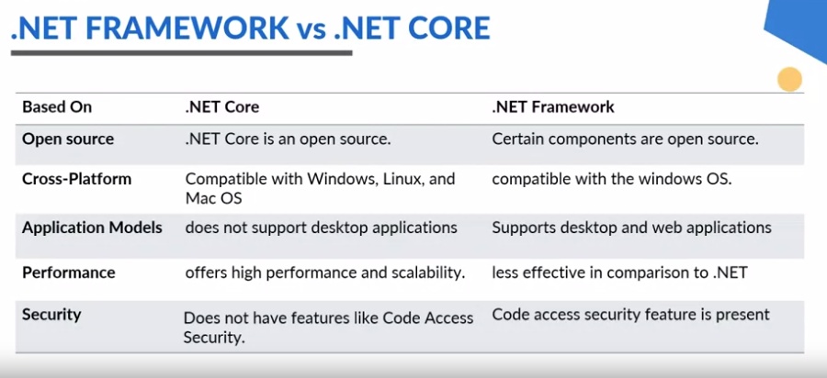

**Step#06**

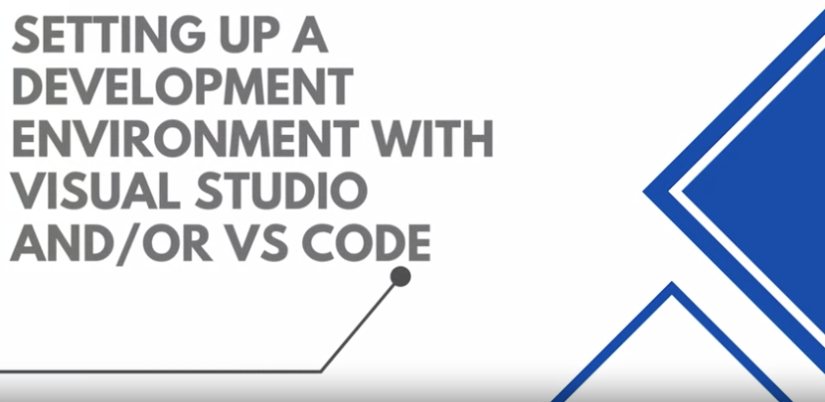

**Write command:** dotnet , dotnet --version

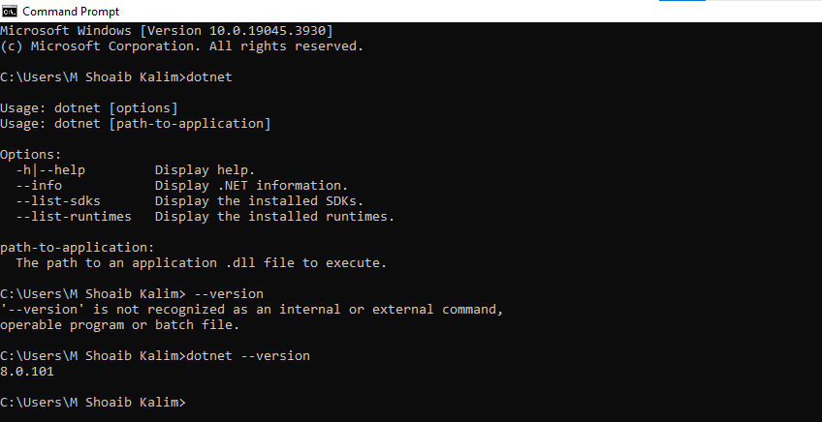

**Cmd write command:** dotnet new list

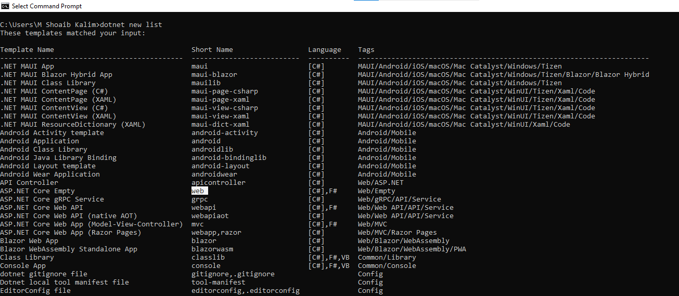

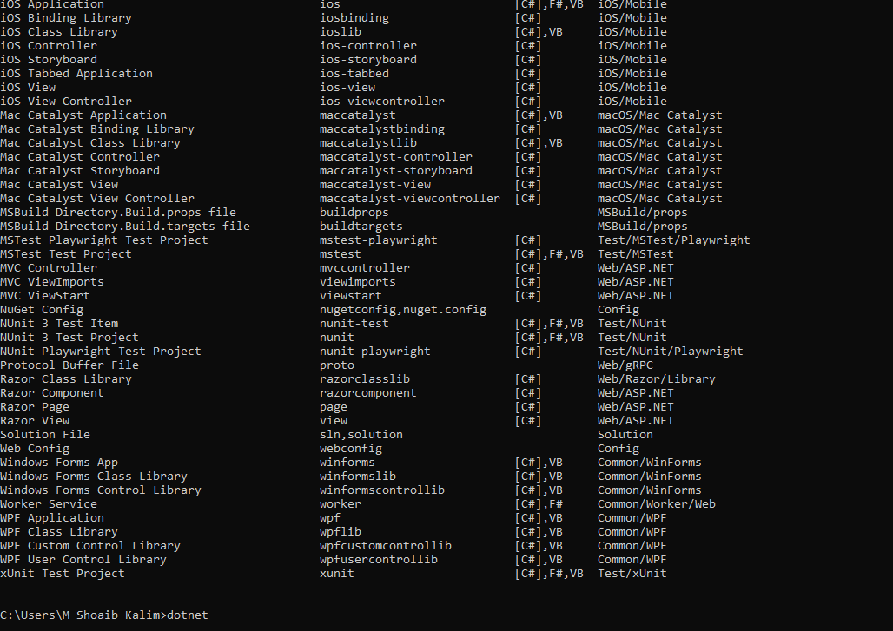

**Step#07**

**-First change directory by :- d:**

**-dotnet new console –n DotNetProject**

**-cd DotNetProject**

**-code .**

**Step#08**

**-After opening vs code go and open terminal and then write command**

**dotnet build**

**-to run code : dotnet run**

**Step#09**

**-Open visual studio code 2022 and go to new project go default setting here.**

**-above run the code and it will go to running your code.**

**Step#10**



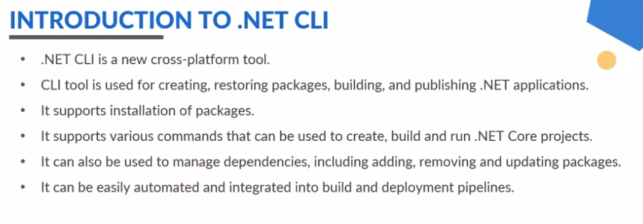

**-Run the commands: dotnet –version, dotnet check its installation.**

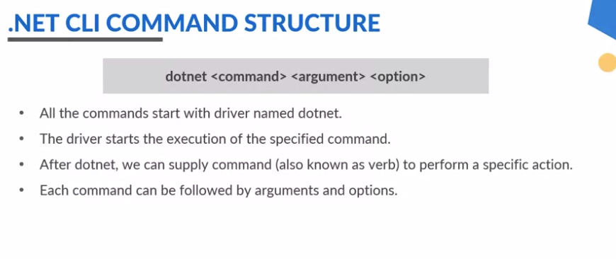

**Step#11**

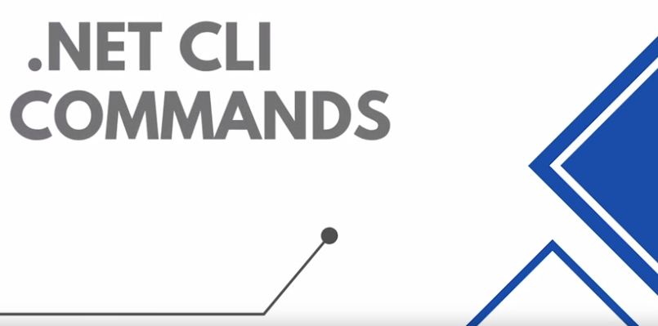

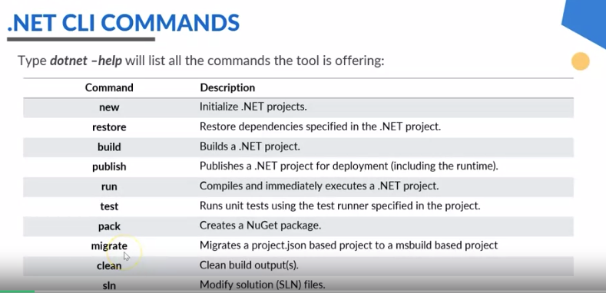

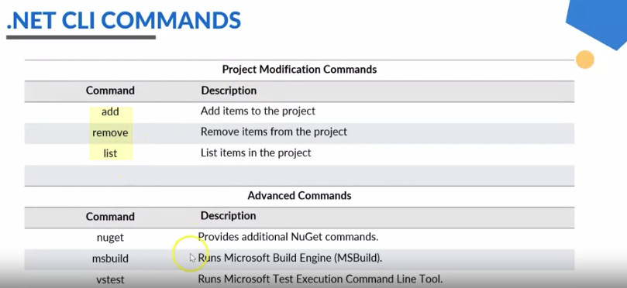

**Step#12**

**Create/Build Web Project:**

**-:d**

**- dotnet new web --name=shoaibProject**

**-cd shoaibProject**

**-dotnet build**

**-dotnet run and here localhost will be given go to check out here.**

**-----------------------------------------------**

**Step#13**

